EXIM BANK

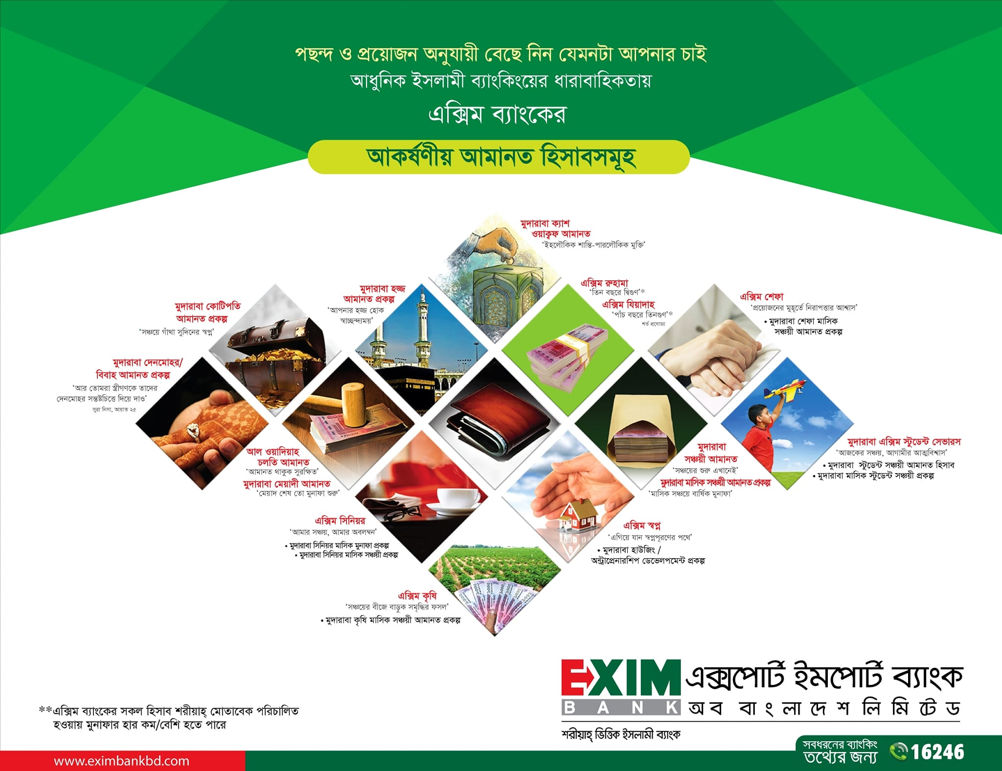

Mudaraba Monthly Saving Scheme (Money Grower)

Savings Period and Monthly Installment Rate
- The savings period is for 3, 5, 8, 10 or 12 years.
- Monthly installment is Tk. 500/-, 1000/-, 2000/- or 5000/-.
- Not less than 65% of investment income shall be distributed among the Murabaha Depositors as per weightage. The deposit will bear weightage 1.16, 1.17, 1.18, 1.19 respectively.
- Bank reserves the right to change the weightage of deposit & percentage of distribution of Investment Income.
Quard Advantage
- After 3 (three) years of savings in this scheme the depositor (if adult) is eligible for a quard up to 90% of his/her deposited amount. In that case, profit rates on the quard will be applicable as per prevailing rate at that time.

Mudaraba Su-Grehini Monthly Savings Scheme

Savings Period and Monthly Installment Rate
- The savings period is for 3,5,8,10 & 12 years.
- Monthly installment is Tk. 200.00 and multiple of Tk. 500.00.
- At least 65% of investment income shall be distributed among the Mudaraba Depositors as per weightage. The Deposit will bear weightage 1.31, 1.33, 1.29, 1.29 and 1.28 respectively.
- Bank reserves the right to change the weightage of deposit and percentage of distribution of Investment Income.
Investment Facility
- The depositor (except minor) can avail investment facility upto 90% of deposited amount after completion of 01 (one) year subject to application of normal terms & conditions of investment the bank .

Mudaraba Femina Monthly Savings Scheme

Savings Period and Monthly Installment Rate
- The savings period is for 3,5,8,10 & 12 years.
- Monthly installment is Tk. 200.00 and multiple of Tk. 500.00.
- At least 65% of investment income shall be distributed among the Mudaraba Depositors as per weightage. The Deposit will bear weightage 1.32, 1.34, 1.30, 1.30 and 1.29 respectively.
- Bank reserves the right to change the weightage of deposit and percentage of distribution of Investment Income.
Investment Facility
- The depositor (except minor) can avail investment facility up to 90% of deposited amount after completion of 01 (one) year subject to application of normal terms & conditions of investment the bank.

Mudaraba Senior Monthly Savings Scheme

Savings Period and Monthly Installment Rate
- The savings period is for1 & 2 years.
- Monthly installment is Tk. 200.00 and multiple of Tk. 500.00.
- At least 65% of investment income shall be distributed among the Mudaraba Depositors as per weightage. The Deposit will bear weightage 1.36 and 1.42 respectively.
- Bank reserves the right to change the weightage of deposit and percentage of distribution of Investment Income.
Investment Facility
- The depositor (except minor) can avail investment facility upto 90% of deposited amount after completion of 01 (one) year subject to application of normal terms & conditions of investment the bank .

Mudaraba Monthly Income Scheme

Feature of Mudaraba Monthly Income Scheme
- Any adult person (individually or jointly) having sound mind can open a Mudaraba Monthly Income Deposit Scheme (MMIDS) account with any branch of the bank by depositing at least Tk. 25,000/- (twenty five thousand) and its multiple amount on any day of the month.
- Benefit against the deposited amount of the account would be credited to the Mudaraba Savings Deposit account of the client maintained with the branch on the same day of every succeeding month as per following rate (changeable as per management decision from time to time):
- One or more account(s) can be opened in the same name at the same branch of the bank.
- Weightage for deposit of Mudaraba Monthly Income Deposit Scheme (MMIDS) will be 1.24.
- A specially designed receipt will be issued favouring the depositor(s) at the time of opening the account. The account holder must preserve the receipt carefully. In case of lost of receipt, bank must be informed without delay and account holder may be allowed a duplicate receipt of the same subject to submission of an indemnity bond. Bank will apply due formalities in this regard.
- Tenure of Mudaraba Monthly Income Deposit Scheme (MMIDS) will be 01 (one) year. Normally, deposited amount of MMIDS is not encashable before maturity. If any depositor intends to encash his/her receipt before maturity (i.e. one year) due to certain unavoidable circumstances, in that case the depositor will not get any profit.
- In case of death of account holder(s), the nominee(s) may continue the account till maturity. In that case, nominee(s) or legal guardian of minor nominee(s) must open a Mudaraba Savings Deposit account with the branch. The branch will credit monthly benefit of deposited amount of the account holder (deceased) to the account opened by the nominee(s)/legal guardian of minor nominee(s).
- Investment against lien of such receipt may be allowed upto 80% of deposited amount subject to application of normal terms & conditions of investment of the bank. Benefit of Mudaraba Monthly Income Deposit Scheme (MMIDS) will be credited to the investment account of the client(s) till full adjustment of total liability.

Mudaraba Su-Grehini Monthly Benefit Scheme

Monthly Benefit
- The monthly benefit period is 1 year.
- Any Housewife having sound mind can open a Mudaraba Su-Grehini Monthly Benefit Scheme with any branch of the bank by depositing at least Tk. 25,000/- (twenty five thousand) and its multiple amount on any day of the month.
- At least 65% of investment income shall be distributed among the Mudaraba Depositors as per weightage. The Deposit will bear weightage 1.27.
- Bank reserves the right to change the weightage of deposit and percentage of distribution of Investment Income.
- Benefit against the deposited amount of the account would be credited to the Mudaraba Savings Deposit Account of the client maintained with the branch on the same day of every succeeding month as per Rate Circular.
- One or more account(s) can be opened in the same name at the same branch of the bank.

Mudaraba Femina Monthly Benefit Scheme

Monthly Benefit
- The monthly benefit period is 1 year.
- Any female employees having sound mind can open a Mudaraba Su-Grehini Monthly Benefit Scheme with any branch of the bank by depositing at least Tk. 25,000/- (twenty five thousand) and its multiple amount on any day of the month.
- At least 65% of investment income shall be distributed among the Mudaraba Depositors as per weightage. The Deposit will bear weightage 1.27.
- Bank reserves the right to change the weightage of deposit and percentage of distribution of Investment Income.
- Benefit against the deposited amount of the account would be credited to the Mudaraba Savings Deposit Account of the client maintained with the branch on the same day of every succeeding month as per Rate Circular.
- One or more account(s) can be opened in the same name at the same branch of the bank.

Mudaraba Senior Monthly Benefit Scheme
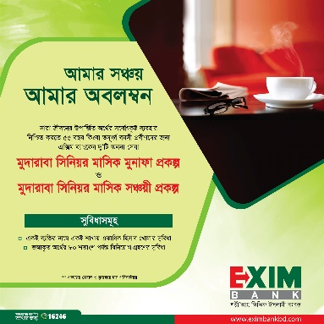
Monthly Benefit
- The monthly benefit period is 1 year.
- Any Senior Citizen having sound mind can open a Mudaraba Senior Monthly Benefit Scheme with any branch of the bank by depositing at least Tk. 25,000/- (twenty five thousand) and its multiple amount on any day of the month.
- At least 65% of investment income shall be distributed among the Mudaraba Depositors as per weightage. The Deposit will bear weightage 1.27.
- Bank reserves the right to change the weightage of deposit and percentage of distribution of Investment Income.
- Benefit against the deposited amount of the account would be credited to the Mudaraba Savings Deposit Account of the client maintained with the branch on the same day of every succeeding month as per Rate Circular.
- One or more account(s) can be opened in the same name at the same branch of the bank.

Mudaraba Multiplus Saving Scheme

Terms and Conditions of the Scheme
- Any adult person (individually or jointly) having sound mind can invest their savings under this scheme.
- The deposit can be made in multiples of Tk. 5,000.00.
- Any customer can open more than one account in a branch in his/her name or in joint names. A Deposit Receipt will be issued at the time of opening the account.
- The period of deposit is 13 (Thirteen) years.

Achievement from the scheme
- payable amount will depend on projection and will be adjusted after the declaration of profit at the end of the year. The weightage of deposit will be 1.17.
- Not less than 65% of investment income shall be distributed among Mudaraba Depositors as per weightage.

In case of premature encashment
- In case of premature encashment before 1 year no profit shall be paid.
- In case of premature encashment after 1 year but before 3 years profit shall be paid at Savings Rate plus 0.75%.
- In case of premature encashment after 3 years but before 5 years profit shall be paid at Savings Rate plus 1.00%.
- In case of premature encashment after 5 years but before 8 years profit shall be paid at Savings Rate plus 1.50%.
- In case of premature encashment after 8 years but before maturity profit shall be paid at Savings Rate plus 2.00%.

Mudaraba Super Saving Scheme
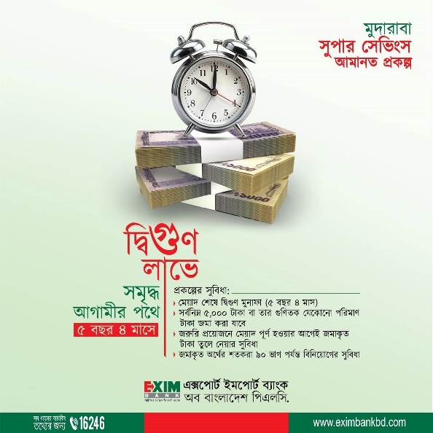
Terms and Conditions of the Scheme
- Any adult person (individually or jointly) having sound mind can open an MSSS Account.
- The deposit can be made in multiples of Tk. 5,000.00.
- Any customer can open more than one account in a branch in his/her name or in joint names. A Deposit Receipt will be issued at the time of opening the account.
- The Deposit will approximately be double on maturity.

Mudaraba Hajj Deposit Scheme

- An adult person having sound mind can open one account only, in his/her single name with any of the branches of the bank.
- The tenure of Mudaraba Hajj Deposit Scheme will be 5, 8, 10, 15 and 20 years. The client may choose any tenure and deposit the prescribed monthly installment to perform Hajj in the predetermined year.
- The client will deposit amount as per installment size prescribed for the year in which the client desires to perform the Hajj.
- Profit against balance of Mudaraba Hajj Deposit Scheme will be credited on daily product basis and it will bear 1.10 profit weightage.
- If any client desires to perform Hajj before his predetermined year, the client will deposit rest of the amount of Hajj expense fixed for that particular year considering the installment amount already deposited by the client.
- If the client fails to perform Hajj for any unavoidable circumstance, the rate of profit prescribed for Mudaraba Hajj Deposit Scheme will not be allowed against his/her deposited amount. In that case, profit against the deposited amount will be credited at the provisional rate of profit prescribed for Mudaraba Savings Account, which was prevailed at the time of opening the Mudaraba Hajj Deposit Scheme.
- No cheque book will be issued to the client as the deposited amount of Mudaraba Hajj Deposit Scheme is not chequeable.
- There will be 12 installments in a year and accordingly 60 installments for 5 years, 120 installments for 10 years and 240 installments for 20 years.
- The client is required to deposit the installment amount on or before 5th day of each month. If the client wants to deposit the installment(s) in advance, the same will be received by the bank but profit will be allowed there-against considering the installment deposited for each succeeding month.
- If the client fails to deposit 03 (three) consecutive installments, the account will be considered as cancelled and profit against balance of deposited amount will be allowed at the provisional rate of profit prescribed for Mudaraba Savings Deposit. If the client fails to deposit two consecutive installments, the account will remain operative. But the recurrence of same instances twice a year or separately 05 (five) times in the selected tenure will lead the Bank to cancel the account.
- If the total deposited amount along with profit given by the bank becomes higher than Hajj expense determined by the respective authority for that particular year, the additional amount will be given to the client. On the other hand, the depositor must bear the additional amount if Hajj expense determined by the respective authority for that particular year becomes higher than the total deposited amount along with profit given by the bank.
- An employee/staff of Exim Bank is also allowed to open this scheme.
- Incase of death of the client, profit against deposited amount will be allowed to the nominee(s) at the provisional rate of profit prescribed for Mudaraba Savings Deposit.

Mudaraba Denmohor / Marriage Deposit Scheme
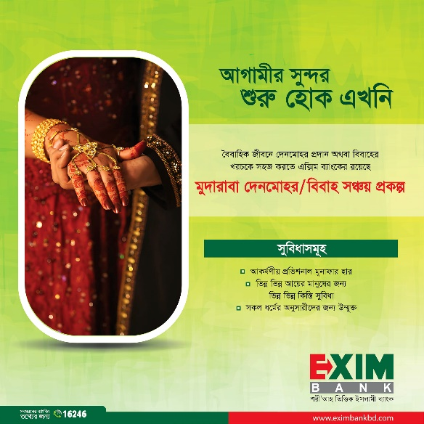
- Mudaraba Denmohor/Marriage Deposit Scheme is a contract between the depositor & EXIM Bank where the account will be governed by the Mudaraba Principles of Islami Shariah.
- In this contract, the depositor will be termed as “Saheb-Al-Maal or owner of fund” and the Bank as “Mudarib or business organizer”.
- An adult person having sound mind can open only one Mudaraba Denmohor Deposit Scheme account in his/her single name and multiple numbers of Mudaraba Marriage Deposit Scheme account in any single name at any branch of the bank with monthly installment as prescribed in clause 21 (twenty o) of this section.
- Marriage account can be opened in the name of a minor and non-muslim too. In case of minor, account to be operated by a guardian.
- The account holder must be Bangladeshi by birth.
- To open Denmohor account by an unmarried male, account to be opened in his own name. In case of married male/female, account to be opened in the name of female. But the account may be operated by the male or any other operator.
- The tenure of Mudaraba Denmohor/Marriage Deposit Scheme will be 3, 5, 8, 10, 12 and 20 years. The depositor will have the option to choose any tenure at the time of opening the account and it cannot be changed afterwards.
- The account is transferable within the branches of the bank under special arrangement.
- Account can be opened in any banking day of the month. But the subsequent installments to be deposited within the 10th day (incase of holiday next working day) of each month.
- Account opened within 10th day of the month will be considered as opened in that particular month. If the account is opened after 10th day of the month, the account will be considered as opened in the following month.
- If a depositor fails to deposit any installment in time, he/she will be penalized with 2.00% per month on outstanding installment amount and must pay the installment(s) due as well as penalized amount with the subsequent installment.
- If the depositor fails to deposit 03 (three) consecutive installments at any point of time, it will cease the right of depositor to remain within the purview of the account and profit against balance of deposited amount will be allowed as per terms & conditions mentioned in the following clause (clause-13).
- Normally, deposited amount of Mudaraba Denmohor/Marriage Deposit Scheme account is not encashable before maturity. If any depositor intends to encash his/her account before maturity due to certain unavoidable circumstances, the following terms & conditions will come into force:
- No profit shall be allowed for premature encashment within 01 (one) year.
- Profit shall be allowed at the provisional rate of Mudaraba Savings Deposit if it is encashed after 01 (one) year but before maturity.
- In case of death of account holder(s), the account shall cease to be operative and the entire deposited amount with profit (if applicable) shall be paid to the nominee(s) or the legal guardian of the nominee (minor) as per Bank’s prevailing rules & regulations. In other cases, the amount shall be released as per rules in force.
- Advance payment for any number of installments will be received by the bank but profit will be allowed there-against considering the installment deposited for each succeeding month.
- No cheque book will be issued under the scheme as the deposited amount of Mudaraba Denmohor/Marriage Deposit Scheme is not chequeable.
- The depositor(s) under this scheme shall get maximum 65% of investment income or the percentage as the bank decides from time to time to their proportion of deposit.

Mudaraba Millionaire Deposit Scheme

Savings Period and Monthly Installment Rate
- The savings period is for 3,5,8,10 & 12 years.
- At least 65% of investment income shall be distributed among the Mudaraba Depositors as per weightage. The Deposit will bear weightage 1.30, 1.31, 1.32, 1.33, 1.34 and 1.35 respectively.
- Bank reserves the right to change the weightage of deposit and percentage of distribution of Investment Income.

Mudaraba Kotipoti Deposit Scheme
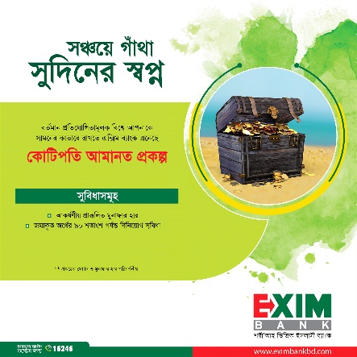
Savings Period and Monthly Installment Rate
- The savings period is for 3,5,8,10,12, 15, 18 & 20 years.
- At least 65% of investment income shall be distributed among the Mudaraba Depositors as per weightage. The Deposit will bear weightage 1.30, 1.31, 1.32, 1.33, 1.34, 1.35, 1.36 and 1.37 respectively.
- Bank reserves the right to change the weightage of deposit and percentage of distribution of Investment Income.

EXIM RUHAMA- Three Years' Probable Double Benefit Scheme

Terms & Conditions of the Scheme
- Any adult person (individually or jointly) having sound mind can open Exim Ruhama Three Years' Probable Double Benefit Scheme account with any branch of the bank by depositing at least Tk. 25,000/- (twenty five thousand) and its multiple amount with monthly installment defined by the bank and its multiple as the case may be (changeable from time to time).
- Account can be opened in the name of a minor under operation of a guardian.
- The account will be operated as per Mudaraba Principles.
- One or more account can be opened in the same name at the same branch of the bank.
- Weightage for Three Years' Probable Double Benefit Scheme account will be 1.29, changeable from time to time.
- A specially designed receipt will be issued favoring the depositor(s) at the time of opening the account. The account holder must preserve the receipt carefully. In case of loss of the receipt, bank must be informed without delay and account holder may be allowed a duplicate receipt of the same subject to submission of an indemnity bond. Bank will apply due formalities in this regard.

EXIM ZIADAH -Five Years' Probable Triple Benefit Scheme:

Terms & Conditions of the Scheme
- Any adult person (individually or jointly) having sound mind can open Exim Ziadah Five Years' Probable Triple Benefit Scheme account with any branch of the bank by depositing at least Tk. 25,000/- (Twenty five thousand) and its multiple amount with monthly installment defined by the bank and its multiple as the case may be (Changeable from time to time).
- Account can be opened in the name of a minor under operation of a guardian.
- The account will be operated as per Mudaraba Principles.
- One or more account can be opened in the same name at the same branch of the bank.
- Weightage for Five Years' Probable Triple Benefit Scheme account will be 1.31, changeable from time to time.
- A specially designed receipt will be issued favoring the depositor(s) at the time of opening the account. The account holder must preserve the receipt carefully. In case of loss of the receipt, bank must be informed without delay and account holder may be allowed a duplicate receipt of the same subject to submission of an indemnity bond. Bank will apply due formalities in this regard.

EXIM KRISHI - Mudaraba Krishi Monthly Deposit Scheme:

Terms & Conditions of the Scheme
- Any existing and potential farmer (individually or jointly) having sound mind can open one or more Mudaraba Krishi Monthly Deposit Scheme in the same name with any branch of the bank with monthly installment of Tk. 50.00 and it's multiple.
- Account can be opened in the name of a minor under operation of a guardian.
- The account will be operated as per Mudaraba Principles.
- One or more account can be opened in the same name at the same branch of the bank.

EXIM SHWAPNO-Mudaraba Housing/Entrepreneurship Development Scheme:

Terms & Conditions of the Scheme
- Any adult person (individually or jointly) having sound mind who has planned to be an entrepreneur, owner of a flat, land, building etc. in future can open one or more Mudaraba Housing / Entrepreneurship Development Scheme with any branch of the bank with monthly installment of Tk. 100.00 and its multiple amount.
- Account can be opened in the name of a minor under operation of a guardian.
- The account will be operated as per Mudaraba Principles.
- One or more account can be opened in the same name at the same branch of the bank.

Mudaraba Shefa Monthly Savings Deposit Scheme

Savings Period and Monthly Installment Rate
- The savings period is for 3, 5 & 8 years.
- Monthly installment is Tk. 200.00 and multiple of Tk. 500.00.
- At least 65% of investment income shall be distributed among the Mudaraba Depositors as per weightage. The Deposit will bear weightage 1.30,1.32 and 1.29 respectively.
- Bank reserves the right to change the weightage of deposit and percentage of distribution of Investment Income.

EXIM Probashi Monthly Benefit Scheme

Monthly Benefit
- Tenure of EXIM Probashi Monthly Benefit Scheme will be 01 (one) year which will be automatically renewed after its maturity.
- Any Non Resident Bangladeshi (NRB) residing abroad & having sound mind can open a EXIM Probashi Monthly Benefit Scheme with any branch of the bank which will be operated on Mudaraba Principle by depositing at least Tk. 25,000/- (twenty five thousand) and its multiple amount on any day of the month.
- Weightage for deposit of EXIM Probashi Monthly Benefit Scheme will be 1.27.
- One or more account(s) can be opened in the same name at the same branch of the bank.
- Bank reserves the right to change the weightage of deposit and percentage of distribution of Investment Income.
- Benefit against the deposited amount of the account will be credited to the Mudaraba Savings Deposit Account of the client maintained with the branch on the same day of every succeeding month as per Rate Circular.

EXIM MIHNAT - Mudaraba Mihnat Monthly Savings Deposit Scheme:

Terms & Conditions of the Scheme
- Any working people of labour-class (individually or jointly) having sound mind can open one or more Mudaraba Mihnat Monthly Savings Deposit Scheme in the same name with any branch of the bank with monthly installment of Tk. 100 only and its multiple but not more than Tk.2500 only.
- Account can be opened in the name of a minor under operation of a guardian.
- The account will be operated as per Mudaraba Principles.
- One or more account can be opened in the same name at the same branch of the bank.

Mudaraba Happiness Monthly Savings Scheme (Inspiring Well-being…)

Key Features
- More savings, more profit.
- Account can be opened by depositing an amount of Tk.1000/- or its multiple (maximum Tk.100000/-).
- Account can be opened in any banking day of the month.
- After opening the account, the subsequent installments will be due on the 1st day of every month, but the depositor may deposit the installment amount and additional amount in any banking day of the month.
- Additional amount (maximum Tk.100000/-) excluding the installment (Initial deposit) can be deposited on any banking day of the month through depositing one or more times.
- Installment or Excess money can be deposited through cash/transfer and BEFTN.

